SOCIALIST REPUBLIC OF VIET NAM
Independence – Freedom – Happiness

CURRICULUM VITAE

PERSONAL DETAILS
- Name: Pham Tien Dat  - Date of Birth: 03 October 2000  - Marital status: Single  - Place of birth: Hà Nội  - Address: Dong Anh Dist., Hanoi  - Email: p.tiendat1102@gmail.com  - Phone: 0858 283 831 | 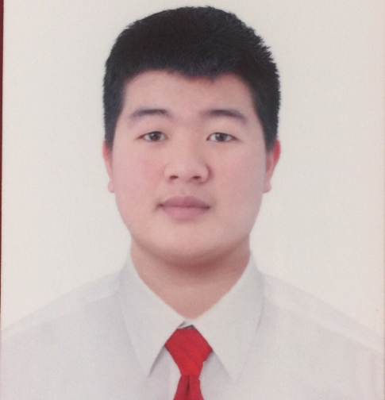
EDUCATION
- From 8/2015 – 4/2018 : Studied Mechanical Engineering at Technique Technology College & Continuing Education Center Dong Anh
WORKING EXPERIENCES
Fushan Technology Viet Nam Co,.. Ltd – Hon Hai Precision Industry
Manufacturing Technician From : 1/2019 - Now
Duties :
- Control all machine , equipment on SMT line
- - Setup model for SMT line
- Control all machine on SMT line ( Printer ESE , SPI Parmi, Mounter Fuji, Reflow Heller, AOI Holly, Parmi )
- Preparation work required Printer , Chip mounter machine
- Chip mounter machine (creat components library, nozzle setup,
- feeder setup, test LCR).
- Setup operation time for Reflow and test profile
- Training new member about SMT line
- Training for all operator in line SMT about new model
- Make report about SMT line to engineer
- Always completed the job as requirement.

* Have basic knowledge about machine :
- Loader_conveyor_unloader machine
- Printer machine (RPM.)
- Solder paste inspection machine (SPI Holly)
- Chip Mounter machine( NXT2,NXT3 )
- Automatic Optical Inspection machine (AOI Holly )
- Reflow (JT KTH )
- X-Ray machine ( X eye 5000BTS )

HANA Micron Viet Nam Co., Ltd – Semiconductor (Finger printer)
QIP Staff ( Quality Innovation Planning Staff ) From : 5/2018 - 12/2018
Duties:
+ QMS monitor & maintain & improve (ISO 9001:2015)...
+ Yield and top defects analysis reports/KPI
+ Defect/Incident/Failure analysis and preventive plan/action.
+ Incoming material quality control/Supplier control (PCB, EMC, Wafer, EMC, Gold wire, Capillary, Mount Tape...)/BTP, OTP, QFN product (finger cost semiconductor) quality issues and follow up for responses
+ Out-going quality control…
+ AQL and sampling plan
+ 6 Sigma and SPC data collections analysis
+ Coordinating the investigation of customer complaints (8D report/CAR report)
+ Internal audit & Customer audit preparation
+ Document control/Updating and training new standard e.g.

Additional skills
- Foreign languages: Japanese (beginner)
- Technical’ skills: Statistics/Analysis software (Mini Tab), Microsoft Office, Design & Graphic software (AutoCAD, Photoshop).
Interests
- High technology in mobile phone, camera and computer.
- Travelling: overseas, countryside and long adventure trips.
- Photography, shopping, Reading and Movies & Music.
- Participate in social activities

I certify that all the details above are completely true with my best knowledge

